FINAL YEAR PROJECT (FYP)

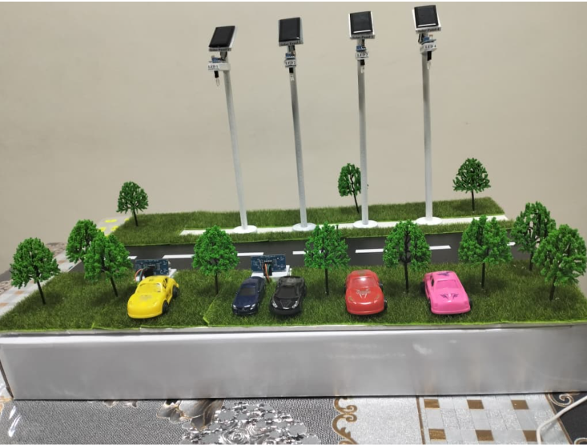

Title: |  | IOT Based Smart Street Lighting Optimization with Solar Panels and Batteries for Energy Efficiency
 | Objective 1: | To design and implement an IoT-based smart and predictive street lighting control mechanism using vehicle detection, real-time clock scheduling, adaptive LED brightness control, and inter-pole lighting coordination to optimise energy usage and enhance road safety.
 | Objective 2: | To analyse and evaluate the performance of the proposed system by monitoring real-time parameters such as lighting state, vehicle detection events, battery status, and energy savings through an IoT-based monitoring platform.
 | Objective 3: | To enhance system sustainability and operational reliability by integrating solar energy harvesting with battery storage and implementing battery-aware control strategies to extend battery lifespan and maximise solar energy utilisation.

This project focuses on developing an intelligent and sustainable street lighting system that combines IoT technology, renewable energy integration, automation, and smart control mechanisms to improve energy efficiency while enhancing road safety. “Here’s how I designed, developed, tested, improved, and presented my engineering project from start to finish.”

Table of Contents

The Inspiration Behind the Project 3
Problems Identified 3
Project Overview 4
Components and Technologies Used 5
Hardware Components 5
Software and Technologies 5
System Design and Prototype Development 6
Presentations and Exhibitions 11
Challenges Faced Throughout the Project 15
Skills and Knowledge Gained 15
Acknowledgements 16
Reflection 17

The Inspiration Behind the Project
Street lighting systems play an important role in improving road visibility and public safety, especially during night-time conditions. However, many conventional streetlights continue operating at full brightness regardless of traffic activity or environmental conditions, leading to unnecessary energy consumption and increased operational costs.
As urban development continues to grow alongside the increasing demand for sustainable infrastructure, I became interested in exploring how engineering technologies could be used to create a smarter and more energy-efficient street lighting solution.
This inspired me to develop an IoT-based smart street lighting system capable of automatically adapting lighting behaviour according to real-time road conditions. By integrating technologies such as vehicle detection, adaptive brightness control, IoT monitoring, solar energy harvesting, and battery storage systems, the project aims to improve energy efficiency while maintaining road safety and supporting sustainable smart city development.

Problems Identified
Several limitations were identified in conventional street lighting systems, including:
- Continuous operation at fixed brightness levels regardless of traffic activity
- High energy consumption and inefficient power utilisation
- Limited use of renewable energy integration
- Lack of intelligent monitoring and adaptive control mechanisms
These challenges highlighted the need for a smarter and more energy-efficient street lighting solution capable of adapting to real-time environmental and traffic conditions.

Project Overview
Conventional street lighting systems typically operate at fixed illumination levels regardless of traffic density or environmental conditions, resulting in significant energy wastage and inefficient power utilisation. With the increasing demand for sustainable and intelligent urban infrastructure, this project focuses on the design and implementation of an IoT-enabled smart solar street lighting system with adaptive energy management and traffic-responsive control.
The proposed system consists of four interconnected streetlight poles powered using photovoltaic solar panels with centralized lithium-ion battery storage, enabling reliable off-grid operation from 7:00 PM to 7:00 AM. An ESP32 microcontroller functions as the main control unit, integrating inputs from Light Dependent Resistor (LDR) sensors, ultrasonic vehicle detection sensors, and an additional sensor mechanism for vehicle speed classification.
To improve energy efficiency, the system employs a multi-mode adaptive brightness control strategy based on battery State of Charge (SoC) and real-time environmental conditions. Three operating modes were developed:
- Day Mode under low-light environmental conditions such as cloudy or rainy weather, maintaining 40% brightness
- Normal Energy Night Mode operating at a baseline brightness of 30% when battery SoC is sufficient
- Low Energy Night Mode reducing baseline brightness to 20% when battery SoC is low to preserve energy and extend battery lifespan
During vehicle detection, the streetlights dynamically increase brightness sequentially across multiple poles, allowing illumination to follow the direction of vehicle movement to improve visibility and road safety while reducing unnecessary energy consumption during low traffic conditions.
The system is also capable of detecting vehicle speed categories, including slow, normal, and fast movement, allowing the lighting reset timing and response behaviour to adapt according to traffic speed conditions for more intelligent operation.
In addition, IoT-based monitoring and data logging were integrated through a mobile monitoring platform and Microsoft Excel to observe and record parameters such as lighting states, battery conditions, vehicle detection events, speed classification results, energy usage, and estimated energy savings in real time.
Overall, the project demonstrates the potential of combining IoT technology, renewable energy systems, adaptive brightness control, vehicle speed detection, and smart automation mechanisms to support more sustainable, energy-efficient, and intelligent urban infrastructure development.

Components and Technologies Used
The development of this project involved the integration of various hardware and software components to support intelligent street lighting control, renewable energy management, and IoT-based monitoring.

Hardware Components
- ESP32 Microcontroller with Expansion Board
- 5V,0.23W Solar Panels
- TP4056 Lithium Battery Charging Module with Protection.
- 3.7V 4000mAh 804060 Lithium Polymer (Li-Po) Rechargeable Battery
- Ultrasonic Ranging Module (HC- SR04)
- MT3608 DC–DC Step-Up (Boost) Converter
- Super Bright White LED
- Light Sensor Module
- Logic-Level N-Channel MOSFET (IRLZ44N)
- Resistors (220 Ω and 1k Ω)
- Real-Time Clock Module (DS3231)
- INA219 Voltage and Current Sensor
- Breadboard, jumper wires, and supporting electronic modules

Software and Technologies
- Arduino IDE
- RemoteXY (IoT Platform)
- Microsoft Excel

These components were integrated together to develop an intelligent and energy-efficient street lighting prototype capable of adaptive lighting control and real-time system monitoring.

System Design and Prototype Development
Following the component selection and system planning stages, the prototype development process was carried out to transform the proposed concept into a functional smart street lighting system.
A miniature road model was designed and constructed to simulate real-world street lighting conditions. Multiple streetlight poles were installed together with vehicle detection sensors, LED lighting modules, solar panels, and battery storage systems to demonstrate the overall system operation. The ESP32 microcontroller was configured as the main control unit to coordinate sensor inputs, adaptive lighting control, inter-pole communication, and IoT monitoring functions.
Circuit integration and wiring connections were carefully developed to ensure stable communication between all hardware components. Several design improvements and modifications were also implemented throughout the development process to improve system performance, responsiveness, and reliability. The prototype development stage provided valuable hands-on experience in embedded systems integration, circuit design, hardware implementation, troubleshooting, and smart automation technologies.

Stage 1: Components Testing and Integration
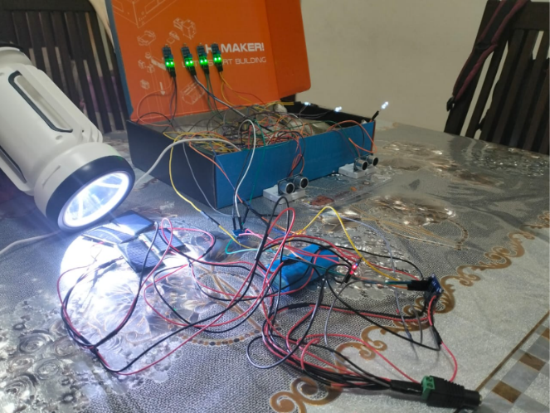

The first stage of the project focused on testing the main hardware components required for the smart street lighting system. Solar panels were tested under direct sunlight conditions to evaluate power generation and charging performance. Ultrasonic sensors were also tested for vehicle detection and distance responsiveness, while LDR sensors were used to detect day and night environmental conditions for automatic lighting control.
During this stage, circuit wiring, sensor calibration, and component integration were carried out to ensure stable communication between the ESP32 microcontroller, sensors, and lighting system before proceeding to the next development phase.
Stage 2: System Testing and Results
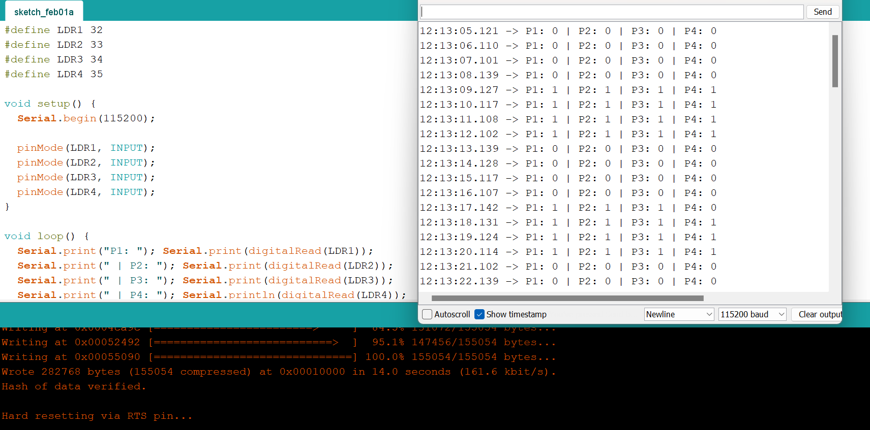

LDR sensor testing for day/night detection
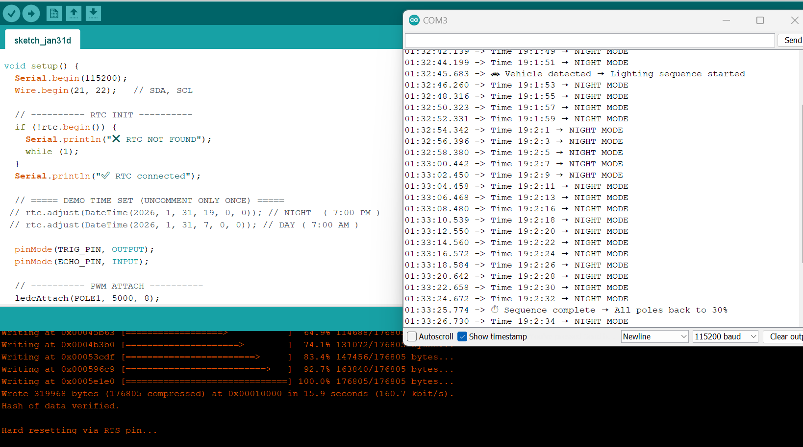

RTC module testing for scheduled operation
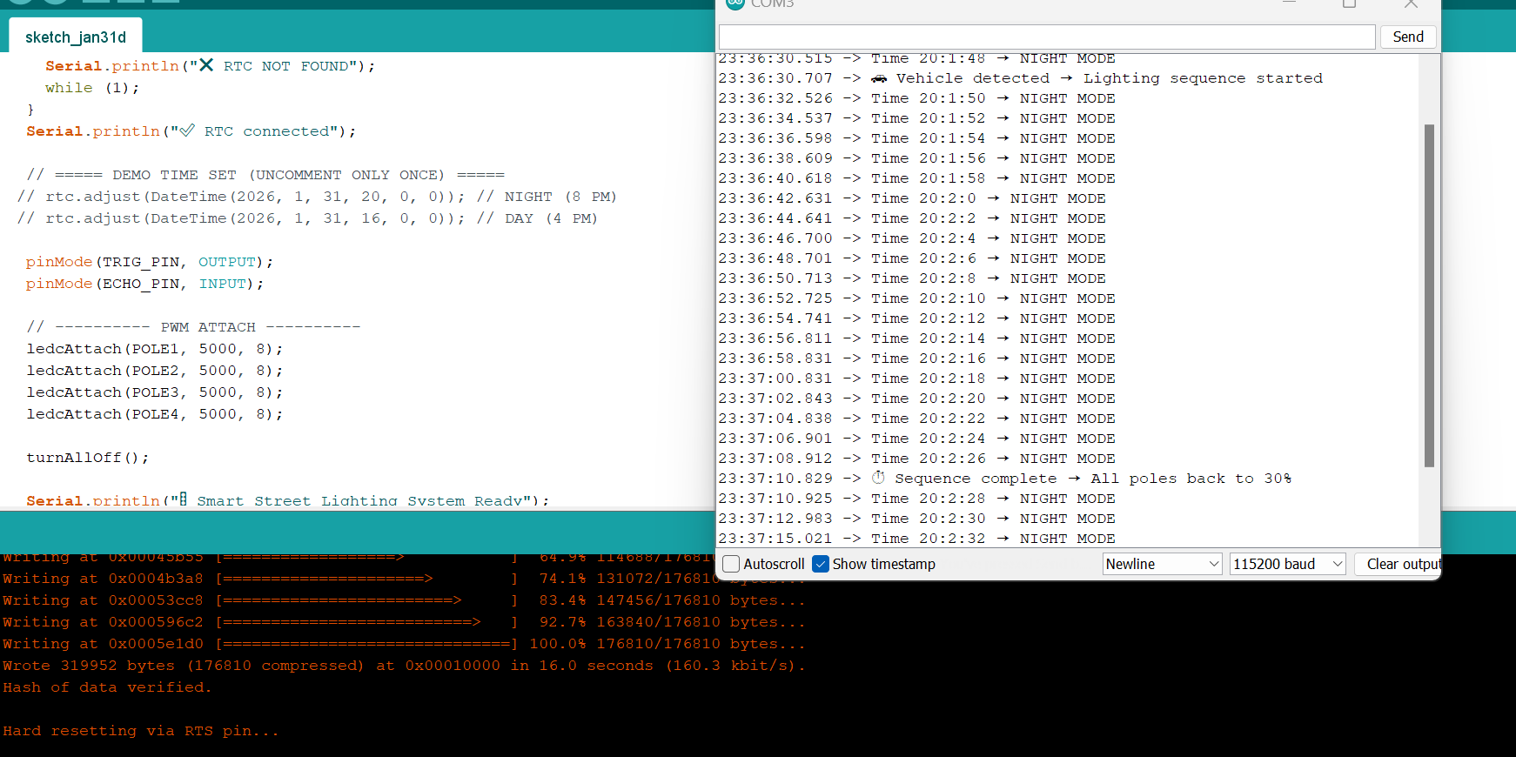

Ultrasonic sensor testing for vehicle detection
The system testing phase focused on validating the functionality and responsiveness of the main sensors and control mechanisms used in the project. Individual testing was carried out for the LDR sensors, RTC module, and ultrasonic sensors to ensure accurate environmental detection, scheduled operation, and vehicle-responsive lighting behaviour before proceeding to full prototype integration.

Stage 3: Prototype Development
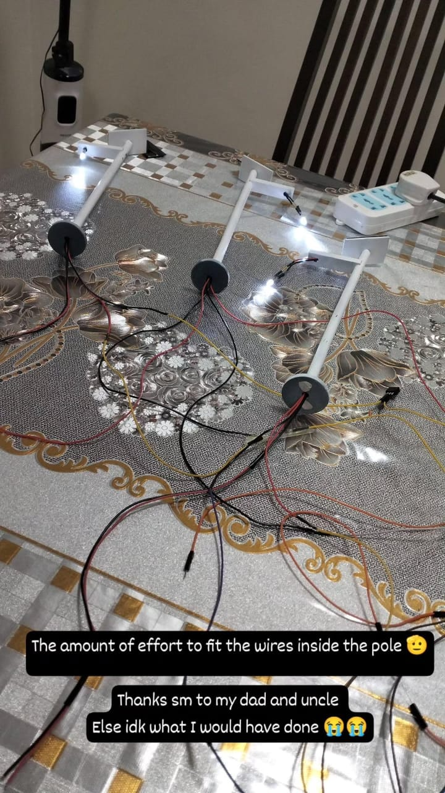
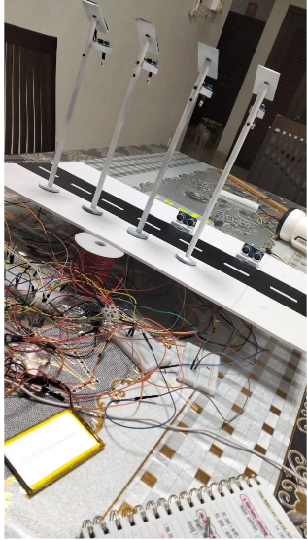

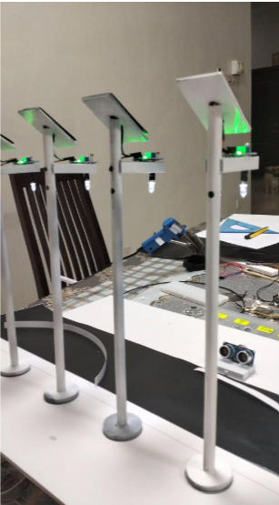
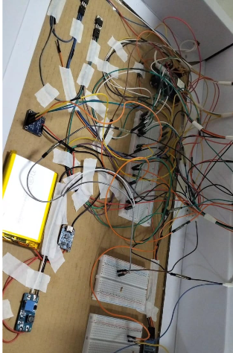
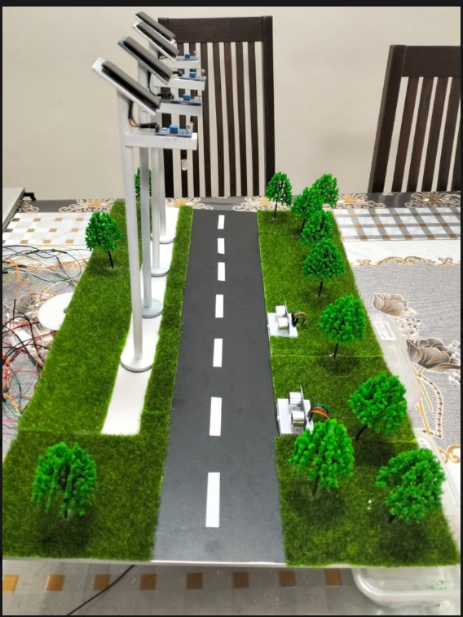
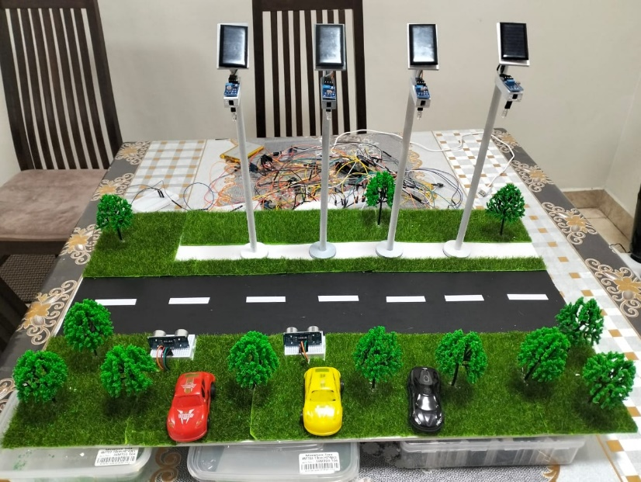
The prototype development stage focused on transforming the proposed system into a functional smart street lighting model. During this phase, the circuit components, sensors, lighting modules, solar panels, and structural elements were gradually integrated and assembled to simulate a real-world street lighting environment. Continuous adjustments and improvements were also carried out to enhance the overall functionality, stability, and appearance of the prototype before final system testing and demonstration.

Stage 4: Final Prototype Development and Demonstration
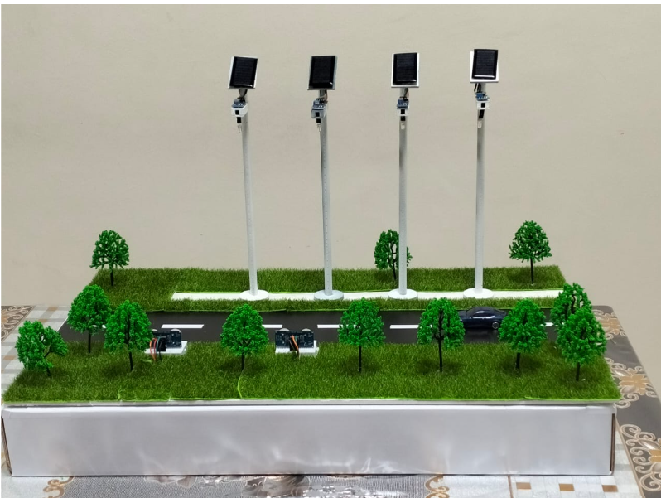
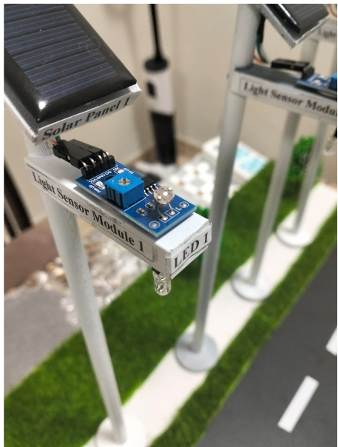

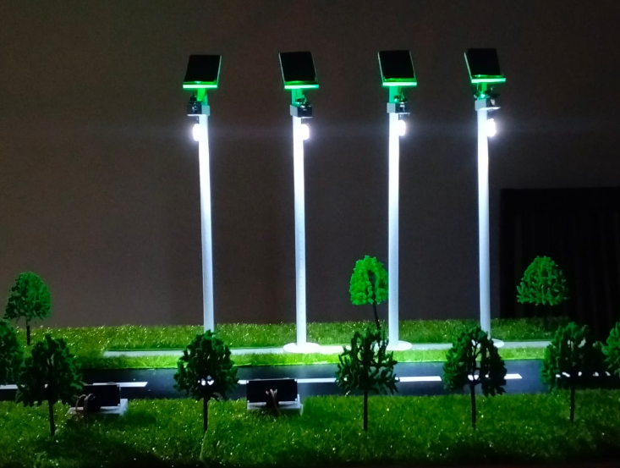
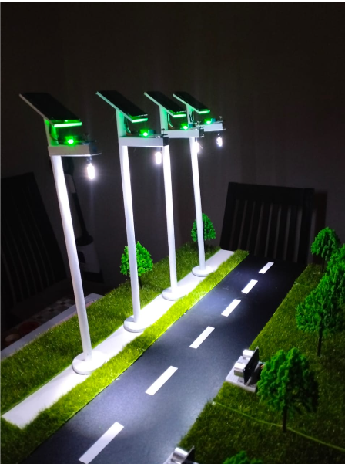
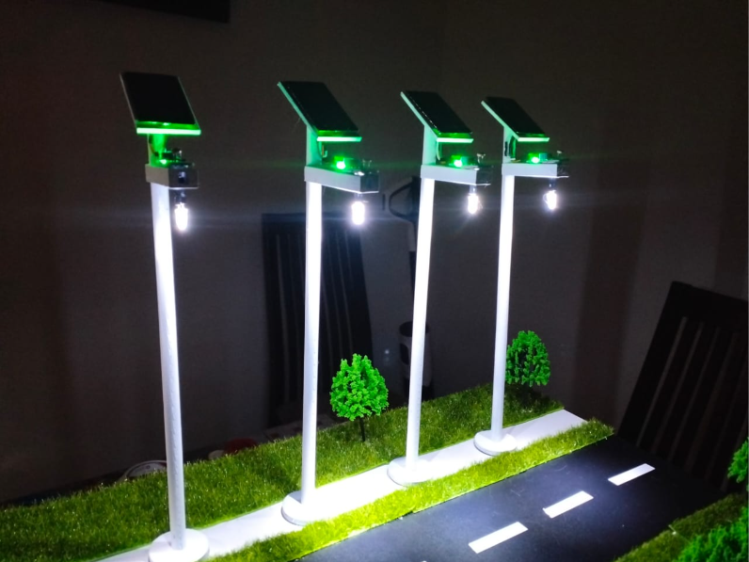
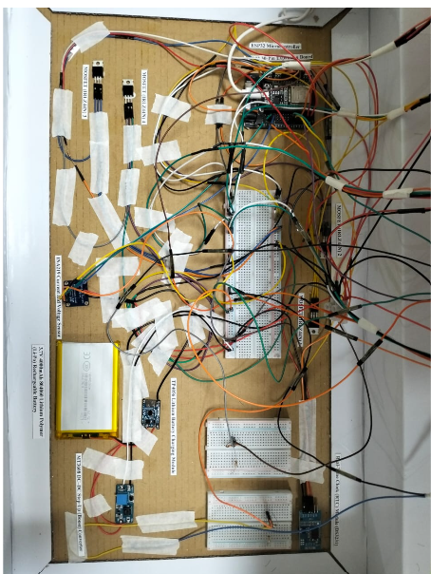

The final prototype development and demonstration stage successfully showcased the complete functionality of the proposed smart street lighting system. Throughout the testing and demonstration process, system performance, adaptive brightness behaviour, battery conditions, vehicle detection events, speed classification results, and energy consumption data were continuously monitored and recorded through the IoT monitoring platform and Microsoft Excel for further analysis and evaluation.
The successful integration of IoT technology, renewable energy systems, adaptive lighting control, vehicle speed detection, and intelligent automation mechanisms demonstrates the potential of the project to contribute towards more sustainable, energy-efficient, and smart urban infrastructure development.

Presentations and Exhibitions
Throughout the development process, the project was presented and demonstrated during multiple academic exhibitions and engineering showcase events. These opportunities allowed the project to be evaluated in a more interactive environment while providing valuable feedback, technical discussions, and exposure to different engineering ideas and innovations.
One of the project showcases was during Technovation Week 2026 at SEGi University Kota Damansara on 31 March 2026, where the prototype and system functionality were demonstrated to lecturers, students, and visitors.
The project was also presented during the Engineering, Science and Technology Exhibition (ESTE) 2026 at MAHSA University on 9 April 2026. During the exhibition, the project successfully received a Bronze Award, recognising the innovation, technical implementation, and sustainability aspects of the proposed IoT-based smart street lighting system.

Technovation Week 2026 31st March 2026
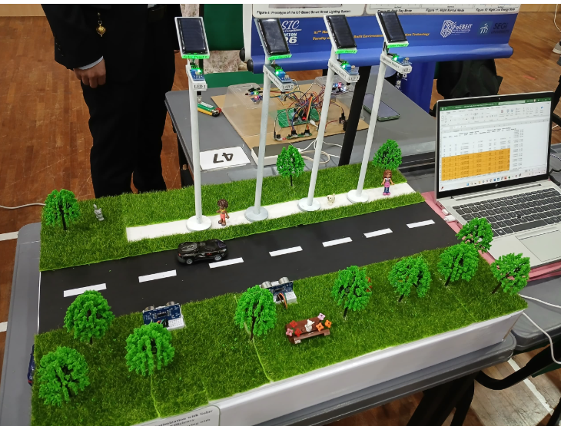

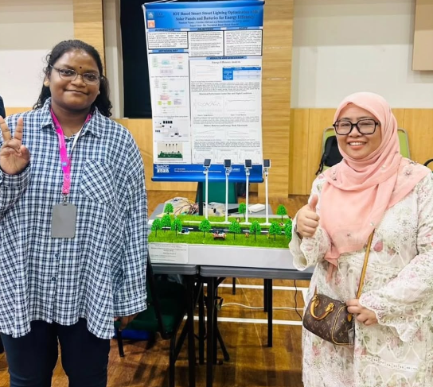

The project was showcased during Technovation Week 2026 held at SEGi University Kota Damansara on 31 March 2026. During the event, the smart street lighting prototype was demonstrated to lecturers, students, and visitors, providing an opportunity to present the completed project, explain the system functionality, and share the overall development journey and technical implementation of the project.

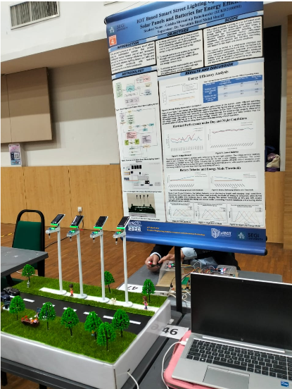

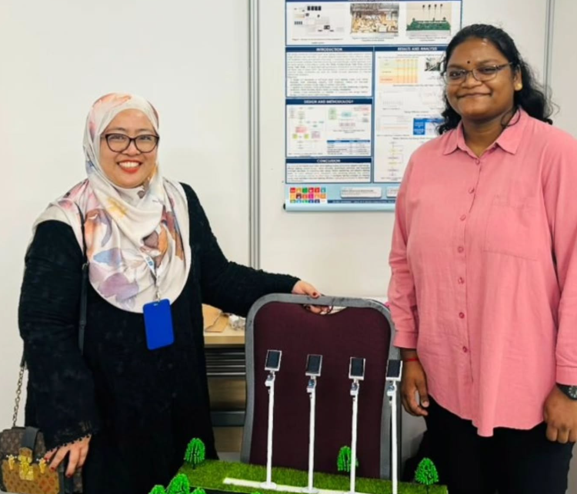
Engineering, Science and Technology Exhibition (ESTE) 2026 at MAHSA University 9th April 2026

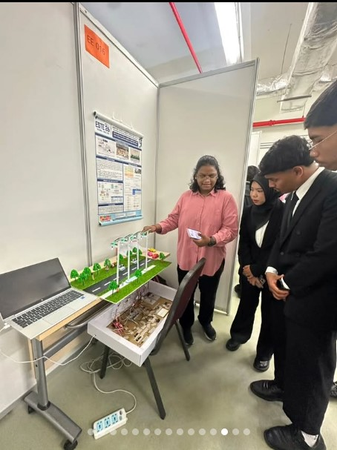
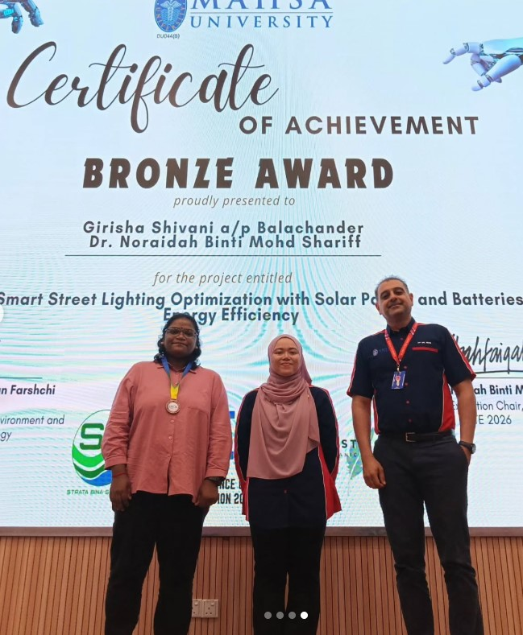

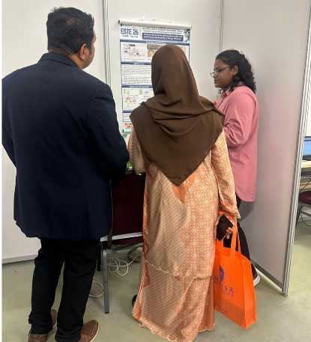


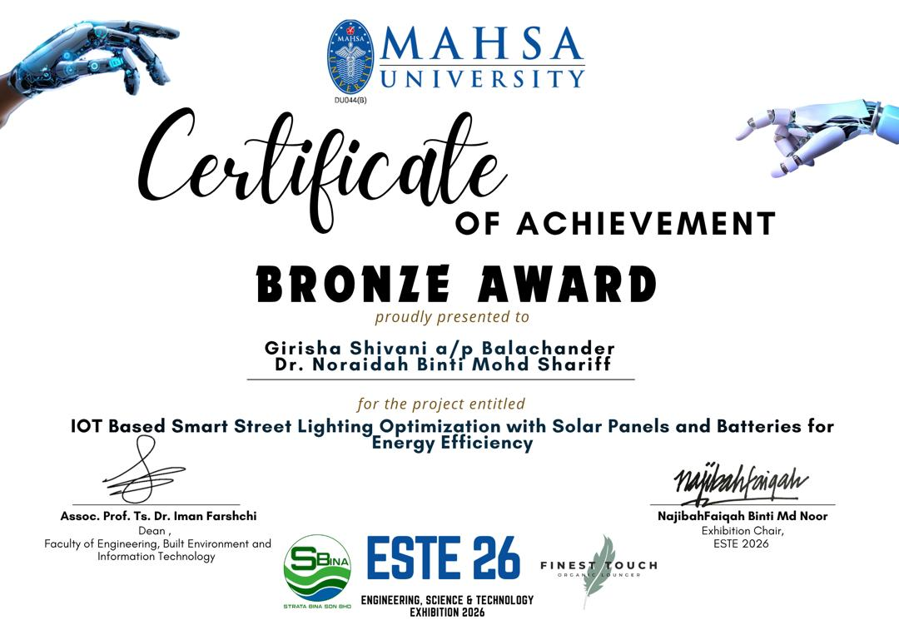
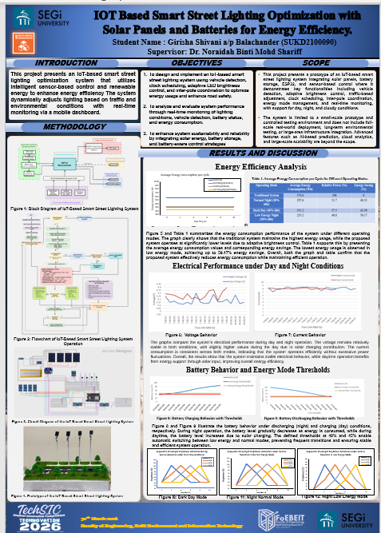
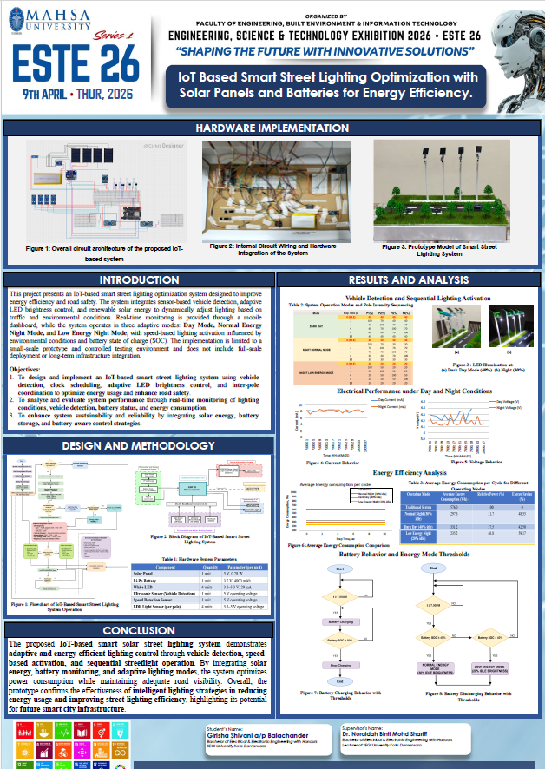
Exhibition Posters

Challenges Faced Throughout the Project
Like many engineering projects, the development process involved various technical challenges and continuous problem-solving throughout different stages of the project.
Some of the main challenges encountered included:
- Sensor calibration and detection accuracy
- Hardware and circuit integration
- Stable communication between components
- Adaptive brightness control implementation
- Battery monitoring and power management
- Troubleshooting software and hardware issues
- Prototype construction and wiring management
Despite these challenges, the troubleshooting and improvement process became one of the most valuable learning experiences throughout the project journey. Each challenge provided opportunities to strengthen technical knowledge, problem-solving skills, and hands-on engineering experience.

Skills and Knowledge Gained
Throughout the development of this project, I gained valuable technical knowledge and hands-on experience in multiple areas of engineering and system integration.
Some of the key areas explored throughout the project include:
- Internet of Things (IoT)
- Embedded systems development
- Renewable energy integration
- Sensor interfacing and calibration
- Adaptive lighting control systems
- Battery and power management
- Circuit design and hardware integration
- Real-time monitoring and data analysis
Beyond technical skills, the project also strengthened important soft skills such as problem-solving, critical thinking, technical documentation, project management, communication, and presentation skills.
Overall, this project provided a meaningful learning experience by combining theoretical engineering concepts with practical real-world implementation and system development.

Acknowledgements
I would like to express my deepest appreciation and sincere gratitude to my supervisor, Dr. Noraidah Binti Mohd Shariff, and my coordinator, Ts. Anis Fariza, for their valuable guidance, advice, continuous encouragement, and unwavering support throughout the completion of this project. Their patience, dedication, and support played an important role in helping me successfully complete this Final Year Project.
I would also like to express my appreciation to Mr. Chong Hock Siong, Ts. Vinukumar Luckose, Dr. Jessie Siaw, Dr. Nur Amirah, and Dr. Nurulazlina binti Ramli for their guidance, constructive feedback, assistance, and encouragement throughout the development of this project. Special appreciation is also extended to the laboratory technician, Mr. Muiz, for his technical assistance and continuous support during the project development process.
My heartfelt gratitude goes to my parents and family for their unconditional love, prayers, patience, encouragement, and unwavering support throughout my academic journey and the completion of this project. Their constant support and belief in me have always been a source of strength and motivation.
Special thanks are also extended to my course mates, Carlos and Ibrahim Tamim, for their assistance, cooperation, idea sharing, and support throughout the development of this project.
Lastly, my sincere thanks go to everyone who directly or indirectly contributed to the successful completion of this project.

Reflection
Working on this Final Year Project has been one of the most meaningful and rewarding experiences throughout my engineering journey. The project allowed me to apply theoretical concepts into a practical real-world system while exploring areas such as IoT, renewable energy integration, smart automation, adaptive control systems, and sustainable engineering technologies.
Beyond the technical development, this journey taught me the importance of patience, continuous learning, teamwork, problem-solving, and perseverance throughout every stage of the project.
I am truly grateful to my lecturers, supervisors, teammates, friends, and everyone who provided guidance, support, and encouragement throughout the development of this project.
Overall, this experience has further strengthened my passion for engineering innovation, smart technologies, and sustainable system development. I look forward to continuing my learning journey and exploring future opportunities related to IoT, embedded systems, renewable energy, automation, and intelligent infrastructure technologies.

